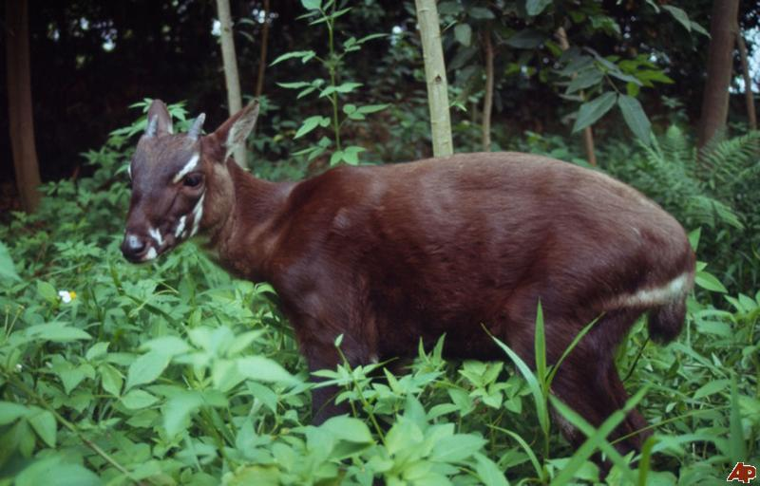This is the Asian Unicorn Like you call a Saola. The reason they call the Asian Unicorn because it’s horns and because it is Asian by Vietnam and Laos. The Animal is not seen very much but this thing here is the rarest mammal in the world, and its family is in Artiodactyla. Artiodactyla is an animal that has horn just like the Asian unicorn. The animal is not just named the Asian unicorn it is call: Saola, Vu Quang Ox, and Vu Quang bovid, also it has a scientific name called Pseudoryx nghetinhensis. This animal is almost getting extinct, it a critically endanger animal because it is catch and kill by humans, trap like snares from humans, and from old age.

This animal has cousin like the goats, cows, and the antelopes. People believe this animal doesn’t exist just like big foot. It is just a myth because they must be all dead by now. The Asian unicorn has 2 questions remains: is it alive or dead? Is all of this just a myth? You can find out more! Look at Vietnam, Laos and Cambodia and check it out!

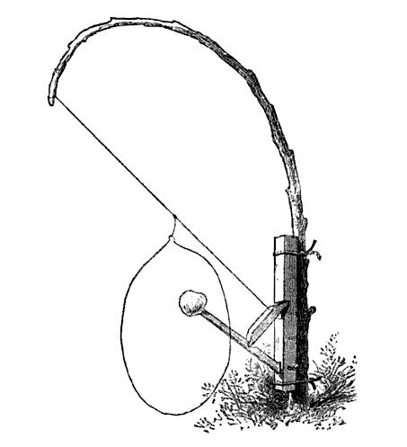Snares are traps for animal like the animal deer, rabbits, tigers, Saola, and animal as the size of a deer. Hunters are the one setting trap for meat, food and warm fur. This type of thing is what you can hunt with. This is a deadly trap like that thing with the stick and the box. This thing is an animal trapping! I wonder why they would set this off on Vietnam. The picture that you seen as the Asian unicorn and said it was a myth, well Vietnam set off camera trap set so you can take a picture. Vietnam said a new specie!

