Floods
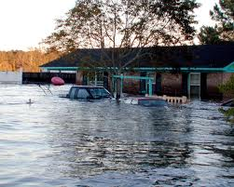
Floods is a type of Disaster and really similar to Tsunami. Floods is really Water or H2O. Water like this or Ocean would be in a Dam - A type barrier that hold back water into Cities, Dam are strong but sometime it break down make a flood. Floods is known for disaster in history and Flood are always starting like right now! People thinks that beavers are useless, but beaver have done something in our life is make Dams. Beaver don’t make hard Dams they make their dams out of branches, So Don’t kill anymore Beavers.

Sewers
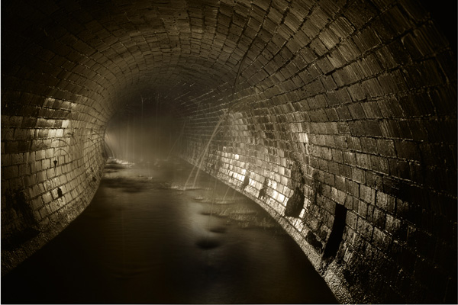 After the flood stop, it would go to the sewers. Sewer may be the weirdest place on earth but save us one time and many time with floods. Sewer is still the creepiest place to go. Some Flood had happen in Japan and more.

The Cause
The cause is Spring Thaw, Winter rainy season, heavy rain, snow melting, and Ice Jam.

a real flood video is right here
http://www.schooltube.com/video/04b75195f87bd1113698/Findlay%20Flood%203/1/11

this is what I got so enjoy!

